Solr Environment setup in Ubuntu

# Ubuntu on VMWare

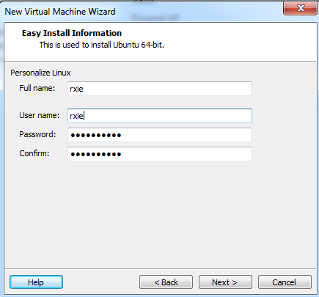

Rxie

X@U

Download Docker for Ubuntu

<https://www.docker.com/community-edition>

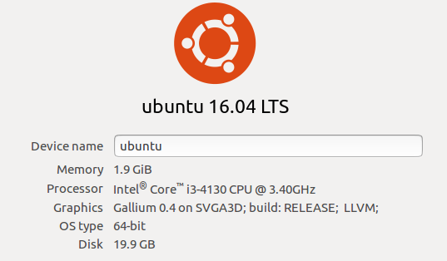

# Install openssh

sudo apt-get install openssh-server

# Access via putty

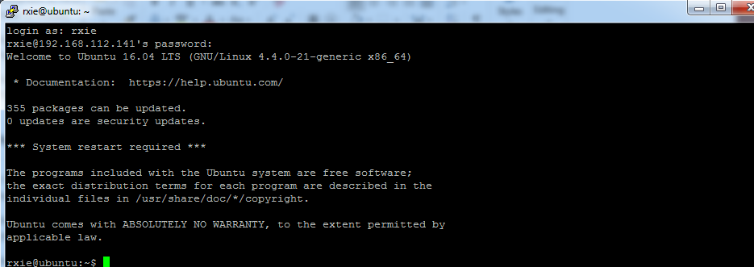

# Install Java 1.8 JRE

sudo apt-get install default-jre

# Solr location

Download:

/opt/solr-7.2.1

After Java 1.8 JRE is installed, start solr:

rxie@ubuntu:~/Downloads/solr-7.2.1$ bin/solr start



Solr introduction tutorial:

<https://www.youtube.com/watch?v=LhN_y1knuVs>

Enter Solr Admin via port 8983

<http://192.168.112.141:8983/solr/#/>

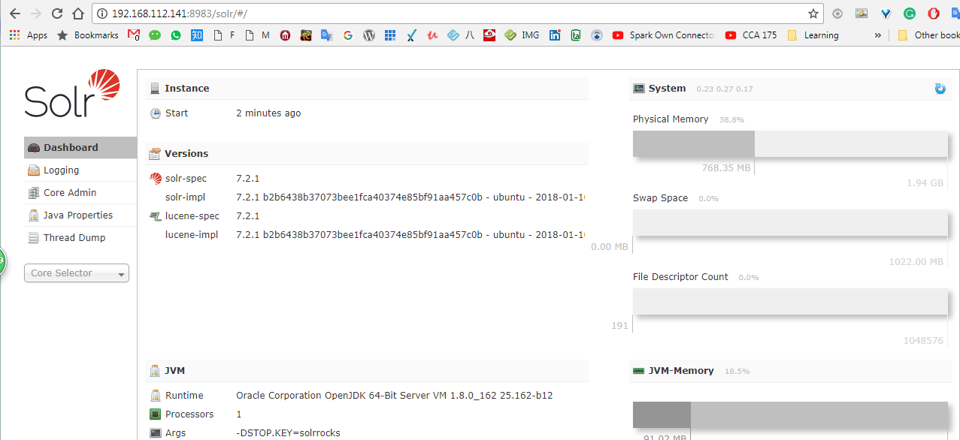

Core: standalone mode

Collection: cluster mode

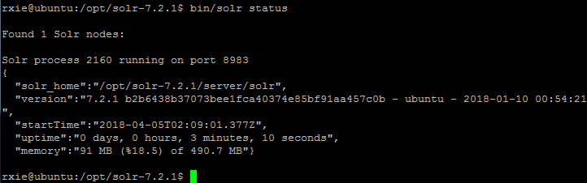

rxie@ubuntu:/opt/solr-7.2.1$ bin/solr status

Found 1 Solr nodes:

Solr process 2160 running on port 8983

{

"solr_home":"/opt/solr-7.2.1/server/solr",

"version":"7.2.1 b2b6438b37073bee1fca40374e85bf91aa457c0b - ubuntu - 2018-01-10 00:54:21",

"startTime":"2018-04-05T02:09:01.377Z",

"uptime":"0 days, 0 hours, 3 minutes, 10 seconds",

"memory":"91 MB (%18.5) of 490.7 MB"}

Cleanup: delete all existing cores to start from scratch

/opt/solr-7.2.1/bin/solr delete -c fix_messages

/opt/solr-7.2.1/bin/solr delete -c fix

/opt/solr-7.2.1/bin/solr delete -c film

Create Core (in command line)

rxie@ubuntu:/opt/solr-7.2.1$ bin/solr create_core -c fix

WARNING: Using _default configset. Data driven schema functionality is enabled by default, which is

NOT RECOMMENDED for production use.

To turn it off:

curl http://localhost:8983/solr/fix /config -d '{"set-user-property": {"update.autoCreateFields":"false"}}'

Created new core 'fix'

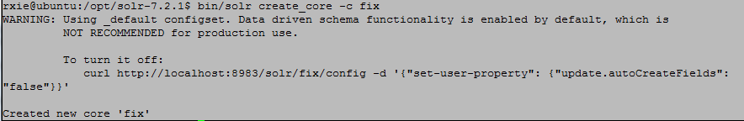

After core is created in command, refresh the Solr Admin page and the core is available there:

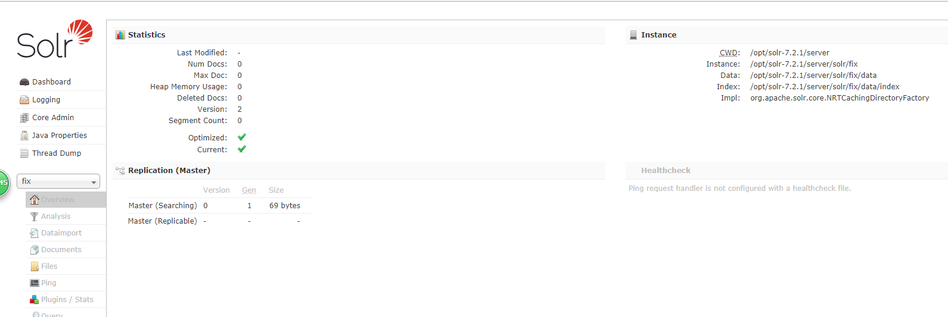

Overview:

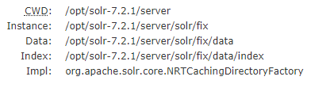

Check the index folder

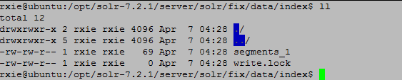

Create the schema:

path: [rxie@ubuntu:/opt/solr-7.2.1/server/solr/fix/conf$](mailto:rxie@ubuntu:/opt/solr-7.2.1/server/solr/fix/conf$)

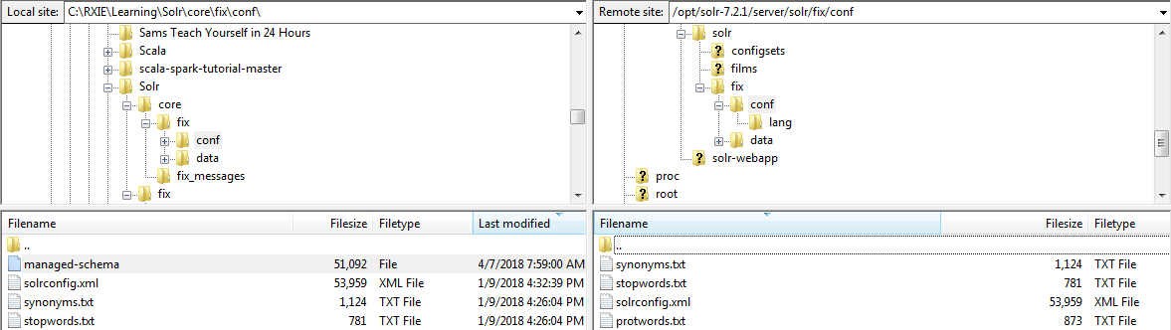

<!--manually added the needed fields to be index'ed on -->

<field name="order_id" type="text_general" indexed="true" stored="false" multiValued="true"/>

<field name="order_version" type="text_general" indexed="true" stored="false" multiValued="true"/>

<field name="trd_date" type="text_general" indexed="true" stored="false" multiValued="true"/>

Double check on Solr Admin: Shut down Solr and restart, the three new fields are added:

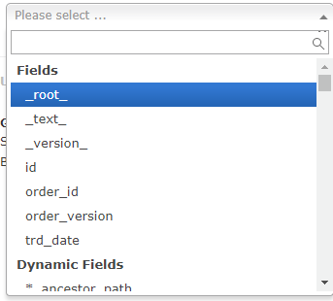

Prepare the test doc test_json_result.json

{"order_id": "337912000000002", "order_version": "", "trd_date": "20180320", "message": "8=FIX.4.49=65335=RIO1=TEST11=33791200000000238=144=2.039=A40=249=VIPER50=JPNIK0154=155=JNI253D8.OS56=XSVC59=075=20180350100=XOSE10039=viperooe10241=viperooe150=A372=D122=20180320-08:08:35.03810066=20180320-08:08:35.03810436=20180320-08:08:35.038202=25375.052=20180320-08:08:35.08860=20180320-08:08:35.08810071=20180320-08:08:35.08811210=33791200000000237=33791200000000210184=337912000000002201=129=410438=RIO.4.510005=17810515=17810518=178581=13660=1021133=G528=P10104=Y10202=APMKTMAKING10208=APAC.VIPER.OOE10217=Y10292=11511032=-1382=010537=XOSE15=JPY167=OPT48=179492540455=17949254022=101456=101151=1.0421=JPN10=200

"}

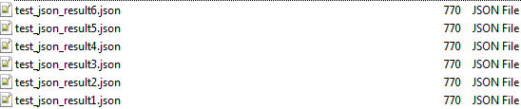

rxie@ubuntu:/opt/solr-7.2.1$ bin/post -c fix /home/data/current/test_json_result1.json

java -classpath /opt/solr-7.2.1/dist/solr-core-7.2.1.jar -Dauto=yes -Dc=fix -Ddata=files org.apache.solr.util.SimplePostTool /home/data/current/test_json_result1.json

SimplePostTool version 5.0.0

Posting files to [base] url http://localhost:8983/solr/fix/update...

Entering auto mode. File endings considered are xml,json,jsonl,csv,pdf,doc,docx,ppt,pptx,xls,xlsx,odt,odp,ods,ott,otp,ots,rtf,htm,html,txt,log

POSTing file test_json_result1.json (application/json) to [base]/json/docs

1 files indexed.

COMMITting Solr index changes to http://localhost:8983/solr/fix/update...

Time spent: 0:00:01.673

rxie@ubuntu:/opt/solr-7.2.1$

Check index folder

rxie@ubuntu:/opt/solr-7.2.1/server/solr/fix/data/index$ pwd

/opt/solr-7.2.1/server/solr/fix/data/index

rxie@ubuntu:/opt/solr-7.2.1/server/solr/fix/data/index$ ll

total 60

drwxrwxr-x 2 rxie rxie 4096 Apr 7 05:03 ./

drwxrwxr-x 5 rxie rxie 4096 Apr 7 04:46 ../

-rw-rw-r-- 1 rxie rxie 617 Apr 7 05:03 _0.fdt

-rw-rw-r-- 1 rxie rxie 84 Apr 7 05:03 _0.fdx

-rw-rw-r-- 1 rxie rxie 699 Apr 7 05:03 _0.fnm

-rw-rw-r-- 1 rxie rxie 110 Apr 7 05:03 _0_Lucene50_0.doc

-rw-rw-r-- 1 rxie rxie 224 Apr 7 05:03 _0_Lucene50_0.pos

-rw-rw-r-- 1 rxie rxie 1353 Apr 7 05:03 _0_Lucene50_0.tim

-rw-rw-r-- 1 rxie rxie 176 Apr 7 05:03 _0_Lucene50_0.tip

-rw-rw-r-- 1 rxie rxie 370 Apr 7 05:03 _0_Lucene70_0.dvd

-rw-rw-r-- 1 rxie rxie 478 Apr 7 05:03 _0_Lucene70_0.dvm

-rw-rw-r-- 1 rxie rxie 59 Apr 7 05:03 _0.nvd

-rw-rw-r-- 1 rxie rxie 166 Apr 7 05:03 _0.nvm

-rw-rw-r-- 1 rxie rxie 540 Apr 7 05:03 _0.si

-rw-rw-r-- 1 rxie rxie 199 Apr 7 05:03 segments_2

-rw-rw-r-- 1 rxie rxie 0 Apr 7 04:46 write.lock

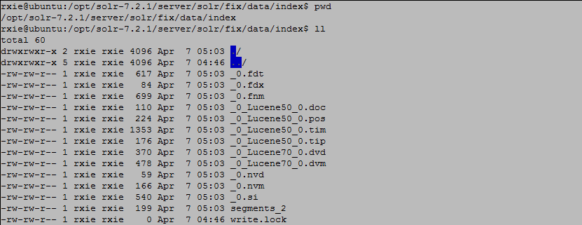

Add the second test doc

bin/post -c fix /home/data/current/test_json_result2.json

Check the index folder

rxie@ubuntu:/opt/solr-7.2.1/server/solr/fix/data/index$ ll

total 108

drwxrwxr-x 2 rxie rxie 4096 Apr 7 05:06 ./

drwxrwxr-x 5 rxie rxie 4096 Apr 7 04:46 ../

-rw-rw-r-- 1 rxie rxie 617 Apr 7 05:03 _0.fdt

-rw-rw-r-- 1 rxie rxie 84 Apr 7 05:03 _0.fdx

-rw-rw-r-- 1 rxie rxie 699 Apr 7 05:03 _0.fnm

-rw-rw-r-- 1 rxie rxie 110 Apr 7 05:03 _0_Lucene50_0.doc

-rw-rw-r-- 1 rxie rxie 224 Apr 7 05:03 _0_Lucene50_0.pos

-rw-rw-r-- 1 rxie rxie 1353 Apr 7 05:03 _0_Lucene50_0.tim

-rw-rw-r-- 1 rxie rxie 176 Apr 7 05:03 _0_Lucene50_0.tip

-rw-rw-r-- 1 rxie rxie 370 Apr 7 05:03 _0_Lucene70_0.dvd

-rw-rw-r-- 1 rxie rxie 478 Apr 7 05:03 _0_Lucene70_0.dvm

-rw-rw-r-- 1 rxie rxie 59 Apr 7 05:03 _0.nvd

-rw-rw-r-- 1 rxie rxie 166 Apr 7 05:03 _0.nvm

-rw-rw-r-- 1 rxie rxie 540 Apr 7 05:03 _0.si

-rw-rw-r-- 1 rxie rxie 617 Apr 7 05:06 _1.fdt

-rw-rw-r-- 1 rxie rxie 84 Apr 7 05:06 _1.fdx

-rw-rw-r-- 1 rxie rxie 699 Apr 7 05:06 _1.fnm

-rw-rw-r-- 1 rxie rxie 110 Apr 7 05:06 _1_Lucene50_0.doc

-rw-rw-r-- 1 rxie rxie 224 Apr 7 05:06 _1_Lucene50_0.pos

-rw-rw-r-- 1 rxie rxie 1353 Apr 7 05:06 _1_Lucene50_0.tim

-rw-rw-r-- 1 rxie rxie 176 Apr 7 05:06 _1_Lucene50_0.tip

-rw-rw-r-- 1 rxie rxie 370 Apr 7 05:06 _1_Lucene70_0.dvd

-rw-rw-r-- 1 rxie rxie 478 Apr 7 05:06 _1_Lucene70_0.dvm

-rw-rw-r-- 1 rxie rxie 59 Apr 7 05:06 _1.nvd

-rw-rw-r-- 1 rxie rxie 166 Apr 7 05:06 _1.nvm

-rw-rw-r-- 1 rxie rxie 540 Apr 7 05:06 _1.si

-rw-rw-r-- 1 rxie rxie 260 Apr 7 05:06 segments_3

-rw-rw-r-- 1 rxie rxie 0 Apr 7 04:46 write.lock

Post third test doc and check the index size

rxie@ubuntu:/opt/solr-7.2.1/server/solr/fix/data/index$ ll

total 156

drwxrwxr-x 2 rxie rxie 4096 Apr 7 05:11 ./

drwxrwxr-x 5 rxie rxie 4096 Apr 7 04:46 ../

-rw-rw-r-- 1 rxie rxie 617 Apr 7 05:03 _0.fdt

-rw-rw-r-- 1 rxie rxie 84 Apr 7 05:03 _0.fdx

-rw-rw-r-- 1 rxie rxie 699 Apr 7 05:03 _0.fnm

-rw-rw-r-- 1 rxie rxie 110 Apr 7 05:03 _0_Lucene50_0.doc

-rw-rw-r-- 1 rxie rxie 224 Apr 7 05:03 _0_Lucene50_0.pos

-rw-rw-r-- 1 rxie rxie 1353 Apr 7 05:03 _0_Lucene50_0.tim

-rw-rw-r-- 1 rxie rxie 176 Apr 7 05:03 _0_Lucene50_0.tip

-rw-rw-r-- 1 rxie rxie 370 Apr 7 05:03 _0_Lucene70_0.dvd

-rw-rw-r-- 1 rxie rxie 478 Apr 7 05:03 _0_Lucene70_0.dvm

-rw-rw-r-- 1 rxie rxie 59 Apr 7 05:03 _0.nvd

-rw-rw-r-- 1 rxie rxie 166 Apr 7 05:03 _0.nvm

-rw-rw-r-- 1 rxie rxie 540 Apr 7 05:03 _0.si

-rw-rw-r-- 1 rxie rxie 617 Apr 7 05:06 _1.fdt

-rw-rw-r-- 1 rxie rxie 84 Apr 7 05:06 _1.fdx

-rw-rw-r-- 1 rxie rxie 699 Apr 7 05:06 _1.fnm

-rw-rw-r-- 1 rxie rxie 110 Apr 7 05:06 _1_Lucene50_0.doc

-rw-rw-r-- 1 rxie rxie 224 Apr 7 05:06 _1_Lucene50_0.pos

-rw-rw-r-- 1 rxie rxie 1353 Apr 7 05:06 _1_Lucene50_0.tim

-rw-rw-r-- 1 rxie rxie 176 Apr 7 05:06 _1_Lucene50_0.tip

-rw-rw-r-- 1 rxie rxie 370 Apr 7 05:06 _1_Lucene70_0.dvd

-rw-rw-r-- 1 rxie rxie 478 Apr 7 05:06 _1_Lucene70_0.dvm

-rw-rw-r-- 1 rxie rxie 59 Apr 7 05:06 _1.nvd

-rw-rw-r-- 1 rxie rxie 166 Apr 7 05:06 _1.nvm

-rw-rw-r-- 1 rxie rxie 540 Apr 7 05:06 _1.si

-rw-rw-r-- 1 rxie rxie 617 Apr 7 05:11 _2.fdt

-rw-rw-r-- 1 rxie rxie 84 Apr 7 05:11 _2.fdx

-rw-rw-r-- 1 rxie rxie 699 Apr 7 05:11 _2.fnm

-rw-rw-r-- 1 rxie rxie 110 Apr 7 05:11 _2_Lucene50_0.doc

-rw-rw-r-- 1 rxie rxie 224 Apr 7 05:11 _2_Lucene50_0.pos

-rw-rw-r-- 1 rxie rxie 1353 Apr 7 05:11 _2_Lucene50_0.tim

-rw-rw-r-- 1 rxie rxie 176 Apr 7 05:11 _2_Lucene50_0.tip

-rw-rw-r-- 1 rxie rxie 370 Apr 7 05:11 _2_Lucene70_0.dvd

-rw-rw-r-- 1 rxie rxie 478 Apr 7 05:11 _2_Lucene70_0.dvm

-rw-rw-r-- 1 rxie rxie 59 Apr 7 05:11 _2.nvd

-rw-rw-r-- 1 rxie rxie 166 Apr 7 05:11 _2.nvm

-rw-rw-r-- 1 rxie rxie 540 Apr 7 05:11 _2.si

-rw-rw-r-- 1 rxie rxie 321 Apr 7 05:11 segments_4

-rw-rw-r-- 1 rxie rxie 0 Apr 7 04:46 write.lock

Add 4th and get the stats as below:

rxie@ubuntu:/opt/solr-7.2.1/server/solr/fix/data/index$ ll

total 204

drwxrwxr-x 2 rxie rxie 4096 Apr 7 05:13 ./

drwxrwxr-x 5 rxie rxie 4096 Apr 7 04:46 ../

-rw-rw-r-- 1 rxie rxie 617 Apr 7 05:03 _0.fdt

-rw-rw-r-- 1 rxie rxie 84 Apr 7 05:03 _0.fdx

-rw-rw-r-- 1 rxie rxie 699 Apr 7 05:03 _0.fnm

-rw-rw-r-- 1 rxie rxie 110 Apr 7 05:03 _0_Lucene50_0.doc

-rw-rw-r-- 1 rxie rxie 224 Apr 7 05:03 _0_Lucene50_0.pos

-rw-rw-r-- 1 rxie rxie 1353 Apr 7 05:03 _0_Lucene50_0.tim

-rw-rw-r-- 1 rxie rxie 176 Apr 7 05:03 _0_Lucene50_0.tip

-rw-rw-r-- 1 rxie rxie 370 Apr 7 05:03 _0_Lucene70_0.dvd

-rw-rw-r-- 1 rxie rxie 478 Apr 7 05:03 _0_Lucene70_0.dvm

-rw-rw-r-- 1 rxie rxie 59 Apr 7 05:03 _0.nvd

-rw-rw-r-- 1 rxie rxie 166 Apr 7 05:03 _0.nvm

-rw-rw-r-- 1 rxie rxie 540 Apr 7 05:03 _0.si

-rw-rw-r-- 1 rxie rxie 617 Apr 7 05:06 _1.fdt

-rw-rw-r-- 1 rxie rxie 84 Apr 7 05:06 _1.fdx

-rw-rw-r-- 1 rxie rxie 699 Apr 7 05:06 _1.fnm

-rw-rw-r-- 1 rxie rxie 110 Apr 7 05:06 _1_Lucene50_0.doc

-rw-rw-r-- 1 rxie rxie 224 Apr 7 05:06 _1_Lucene50_0.pos

-rw-rw-r-- 1 rxie rxie 1353 Apr 7 05:06 _1_Lucene50_0.tim

-rw-rw-r-- 1 rxie rxie 176 Apr 7 05:06 _1_Lucene50_0.tip

-rw-rw-r-- 1 rxie rxie 370 Apr 7 05:06 _1_Lucene70_0.dvd

-rw-rw-r-- 1 rxie rxie 478 Apr 7 05:06 _1_Lucene70_0.dvm

-rw-rw-r-- 1 rxie rxie 59 Apr 7 05:06 _1.nvd

-rw-rw-r-- 1 rxie rxie 166 Apr 7 05:06 _1.nvm

-rw-rw-r-- 1 rxie rxie 540 Apr 7 05:06 _1.si

-rw-rw-r-- 1 rxie rxie 617 Apr 7 05:11 _2.fdt

-rw-rw-r-- 1 rxie rxie 84 Apr 7 05:11 _2.fdx

-rw-rw-r-- 1 rxie rxie 699 Apr 7 05:11 _2.fnm

-rw-rw-r-- 1 rxie rxie 110 Apr 7 05:11 _2_Lucene50_0.doc

-rw-rw-r-- 1 rxie rxie 224 Apr 7 05:11 _2_Lucene50_0.pos

-rw-rw-r-- 1 rxie rxie 1353 Apr 7 05:11 _2_Lucene50_0.tim

-rw-rw-r-- 1 rxie rxie 176 Apr 7 05:11 _2_Lucene50_0.tip

-rw-rw-r-- 1 rxie rxie 370 Apr 7 05:11 _2_Lucene70_0.dvd

-rw-rw-r-- 1 rxie rxie 478 Apr 7 05:11 _2_Lucene70_0.dvm

-rw-rw-r-- 1 rxie rxie 59 Apr 7 05:11 _2.nvd

-rw-rw-r-- 1 rxie rxie 166 Apr 7 05:11 _2.nvm

-rw-rw-r-- 1 rxie rxie 540 Apr 7 05:11 _2.si

-rw-rw-r-- 1 rxie rxie 617 Apr 7 05:13 _3.fdt

-rw-rw-r-- 1 rxie rxie 84 Apr 7 05:13 _3.fdx

-rw-rw-r-- 1 rxie rxie 699 Apr 7 05:13 _3.fnm

-rw-rw-r-- 1 rxie rxie 110 Apr 7 05:13 _3_Lucene50_0.doc

-rw-rw-r-- 1 rxie rxie 224 Apr 7 05:13 _3_Lucene50_0.pos

-rw-rw-r-- 1 rxie rxie 1353 Apr 7 05:13 _3_Lucene50_0.tim

-rw-rw-r-- 1 rxie rxie 176 Apr 7 05:13 _3_Lucene50_0.tip

-rw-rw-r-- 1 rxie rxie 370 Apr 7 05:13 _3_Lucene70_0.dvd

-rw-rw-r-- 1 rxie rxie 478 Apr 7 05:13 _3_Lucene70_0.dvm

-rw-rw-r-- 1 rxie rxie 59 Apr 7 05:13 _3.nvd

-rw-rw-r-- 1 rxie rxie 166 Apr 7 05:13 _3.nvm

-rw-rw-r-- 1 rxie rxie 540 Apr 7 05:13 _3.si

-rw-rw-r-- 1 rxie rxie 382 Apr 7 05:13 segments_5

Add 5th and get the stats as below:

rxie@ubuntu:/opt/solr-7.2.1/server/solr/fix/data/index$ ll

total 252

drwxrwxr-x 2 rxie rxie 4096 Apr 7 05:16 ./

drwxrwxr-x 5 rxie rxie 4096 Apr 7 04:46 ../

-rw-rw-r-- 1 rxie rxie 617 Apr 7 05:03 _0.fdt

-rw-rw-r-- 1 rxie rxie 84 Apr 7 05:03 _0.fdx

-rw-rw-r-- 1 rxie rxie 699 Apr 7 05:03 _0.fnm

-rw-rw-r-- 1 rxie rxie 110 Apr 7 05:03 _0_Lucene50_0.doc

-rw-rw-r-- 1 rxie rxie 224 Apr 7 05:03 _0_Lucene50_0.pos

-rw-rw-r-- 1 rxie rxie 1353 Apr 7 05:03 _0_Lucene50_0.tim

-rw-rw-r-- 1 rxie rxie 176 Apr 7 05:03 _0_Lucene50_0.tip

-rw-rw-r-- 1 rxie rxie 370 Apr 7 05:03 _0_Lucene70_0.dvd

-rw-rw-r-- 1 rxie rxie 478 Apr 7 05:03 _0_Lucene70_0.dvm

-rw-rw-r-- 1 rxie rxie 59 Apr 7 05:03 _0.nvd

-rw-rw-r-- 1 rxie rxie 166 Apr 7 05:03 _0.nvm

-rw-rw-r-- 1 rxie rxie 540 Apr 7 05:03 _0.si

-rw-rw-r-- 1 rxie rxie 617 Apr 7 05:06 _1.fdt

-rw-rw-r-- 1 rxie rxie 84 Apr 7 05:06 _1.fdx

-rw-rw-r-- 1 rxie rxie 699 Apr 7 05:06 _1.fnm

-rw-rw-r-- 1 rxie rxie 110 Apr 7 05:06 _1_Lucene50_0.doc

-rw-rw-r-- 1 rxie rxie 224 Apr 7 05:06 _1_Lucene50_0.pos

-rw-rw-r-- 1 rxie rxie 1353 Apr 7 05:06 _1_Lucene50_0.tim

-rw-rw-r-- 1 rxie rxie 176 Apr 7 05:06 _1_Lucene50_0.tip

-rw-rw-r-- 1 rxie rxie 370 Apr 7 05:06 _1_Lucene70_0.dvd

-rw-rw-r-- 1 rxie rxie 478 Apr 7 05:06 _1_Lucene70_0.dvm

-rw-rw-r-- 1 rxie rxie 59 Apr 7 05:06 _1.nvd

-rw-rw-r-- 1 rxie rxie 166 Apr 7 05:06 _1.nvm

-rw-rw-r-- 1 rxie rxie 540 Apr 7 05:06 _1.si

-rw-rw-r-- 1 rxie rxie 617 Apr 7 05:11 _2.fdt

-rw-rw-r-- 1 rxie rxie 84 Apr 7 05:11 _2.fdx

-rw-rw-r-- 1 rxie rxie 699 Apr 7 05:11 _2.fnm

-rw-rw-r-- 1 rxie rxie 110 Apr 7 05:11 _2_Lucene50_0.doc

-rw-rw-r-- 1 rxie rxie 224 Apr 7 05:11 _2_Lucene50_0.pos

-rw-rw-r-- 1 rxie rxie 1353 Apr 7 05:11 _2_Lucene50_0.tim

-rw-rw-r-- 1 rxie rxie 176 Apr 7 05:11 _2_Lucene50_0.tip

-rw-rw-r-- 1 rxie rxie 370 Apr 7 05:11 _2_Lucene70_0.dvd

-rw-rw-r-- 1 rxie rxie 478 Apr 7 05:11 _2_Lucene70_0.dvm

-rw-rw-r-- 1 rxie rxie 59 Apr 7 05:11 _2.nvd

-rw-rw-r-- 1 rxie rxie 166 Apr 7 05:11 _2.nvm

-rw-rw-r-- 1 rxie rxie 540 Apr 7 05:11 _2.si

-rw-rw-r-- 1 rxie rxie 617 Apr 7 05:13 _3.fdt

-rw-rw-r-- 1 rxie rxie 84 Apr 7 05:13 _3.fdx

-rw-rw-r-- 1 rxie rxie 699 Apr 7 05:13 _3.fnm

-rw-rw-r-- 1 rxie rxie 110 Apr 7 05:13 _3_Lucene50_0.doc

-rw-rw-r-- 1 rxie rxie 224 Apr 7 05:13 _3_Lucene50_0.pos

-rw-rw-r-- 1 rxie rxie 1353 Apr 7 05:13 _3_Lucene50_0.tim

-rw-rw-r-- 1 rxie rxie 176 Apr 7 05:13 _3_Lucene50_0.tip

-rw-rw-r-- 1 rxie rxie 370 Apr 7 05:13 _3_Lucene70_0.dvd

-rw-rw-r-- 1 rxie rxie 478 Apr 7 05:13 _3_Lucene70_0.dvm

-rw-rw-r-- 1 rxie rxie 59 Apr 7 05:13 _3.nvd

-rw-rw-r-- 1 rxie rxie 166 Apr 7 05:13 _3.nvm

-rw-rw-r-- 1 rxie rxie 540 Apr 7 05:13 _3.si

-rw-rw-r-- 1 rxie rxie 617 Apr 7 05:16 _4.fdt

-rw-rw-r-- 1 rxie rxie 84 Apr 7 05:16 _4.fdx

-rw-rw-r-- 1 rxie rxie 699 Apr 7 05:16 _4.fnm

-rw-rw-r-- 1 rxie rxie 110 Apr 7 05:16 _4_Lucene50_0.doc

-rw-rw-r-- 1 rxie rxie 224 Apr 7 05:16 _4_Lucene50_0.pos

-rw-rw-r-- 1 rxie rxie 1353 Apr 7 05:16 _4_Lucene50_0.tim

-rw-rw-r-- 1 rxie rxie 176 Apr 7 05:16 _4_Lucene50_0.tip

-rw-rw-r-- 1 rxie rxie 370 Apr 7 05:16 _4_Lucene70_0.dvd

-rw-rw-r-- 1 rxie rxie 478 Apr 7 05:16 _4_Lucene70_0.dvm

-rw-rw-r-- 1 rxie rxie 59 Apr 7 05:16 _4.nvd

-rw-rw-r-- 1 rxie rxie 166 Apr 7 05:16 _4.nvm

-rw-rw-r-- 1 rxie rxie 540 Apr 7 05:16 _4.si

-rw-rw-r-- 1 rxie rxie 443 Apr 7 05:16 segments_6

-rw-rw-r-- 1 rxie rxie 0 Apr 7 04:46 write.lock

6th doc added

rxie@ubuntu:/opt/solr-7.2.1/server/solr/fix/data/index$ ll

total 300

drwxrwxr-x 2 rxie rxie 4096 Apr 7 05:22 ./

drwxrwxr-x 5 rxie rxie 4096 Apr 7 04:46 ../

-rw-rw-r-- 1 rxie rxie 617 Apr 7 05:03 _0.fdt

-rw-rw-r-- 1 rxie rxie 84 Apr 7 05:03 _0.fdx

-rw-rw-r-- 1 rxie rxie 699 Apr 7 05:03 _0.fnm

-rw-rw-r-- 1 rxie rxie 110 Apr 7 05:03 _0_Lucene50_0.doc

-rw-rw-r-- 1 rxie rxie 224 Apr 7 05:03 _0_Lucene50_0.pos

-rw-rw-r-- 1 rxie rxie 1353 Apr 7 05:03 _0_Lucene50_0.tim

-rw-rw-r-- 1 rxie rxie 176 Apr 7 05:03 _0_Lucene50_0.tip

-rw-rw-r-- 1 rxie rxie 370 Apr 7 05:03 _0_Lucene70_0.dvd

-rw-rw-r-- 1 rxie rxie 478 Apr 7 05:03 _0_Lucene70_0.dvm

-rw-rw-r-- 1 rxie rxie 59 Apr 7 05:03 _0.nvd

-rw-rw-r-- 1 rxie rxie 166 Apr 7 05:03 _0.nvm

-rw-rw-r-- 1 rxie rxie 540 Apr 7 05:03 _0.si

-rw-rw-r-- 1 rxie rxie 617 Apr 7 05:06 _1.fdt

-rw-rw-r-- 1 rxie rxie 84 Apr 7 05:06 _1.fdx

-rw-rw-r-- 1 rxie rxie 699 Apr 7 05:06 _1.fnm

-rw-rw-r-- 1 rxie rxie 110 Apr 7 05:06 _1_Lucene50_0.doc

-rw-rw-r-- 1 rxie rxie 224 Apr 7 05:06 _1_Lucene50_0.pos

-rw-rw-r-- 1 rxie rxie 1353 Apr 7 05:06 _1_Lucene50_0.tim

-rw-rw-r-- 1 rxie rxie 176 Apr 7 05:06 _1_Lucene50_0.tip

-rw-rw-r-- 1 rxie rxie 370 Apr 7 05:06 _1_Lucene70_0.dvd

-rw-rw-r-- 1 rxie rxie 478 Apr 7 05:06 _1_Lucene70_0.dvm

-rw-rw-r-- 1 rxie rxie 59 Apr 7 05:06 _1.nvd

-rw-rw-r-- 1 rxie rxie 166 Apr 7 05:06 _1.nvm

-rw-rw-r-- 1 rxie rxie 540 Apr 7 05:06 _1.si

-rw-rw-r-- 1 rxie rxie 617 Apr 7 05:11 _2.fdt

-rw-rw-r-- 1 rxie rxie 84 Apr 7 05:11 _2.fdx

-rw-rw-r-- 1 rxie rxie 699 Apr 7 05:11 _2.fnm

-rw-rw-r-- 1 rxie rxie 110 Apr 7 05:11 _2_Lucene50_0.doc

-rw-rw-r-- 1 rxie rxie 224 Apr 7 05:11 _2_Lucene50_0.pos

-rw-rw-r-- 1 rxie rxie 1353 Apr 7 05:11 _2_Lucene50_0.tim

-rw-rw-r-- 1 rxie rxie 176 Apr 7 05:11 _2_Lucene50_0.tip

-rw-rw-r-- 1 rxie rxie 370 Apr 7 05:11 _2_Lucene70_0.dvd

-rw-rw-r-- 1 rxie rxie 478 Apr 7 05:11 _2_Lucene70_0.dvm

-rw-rw-r-- 1 rxie rxie 59 Apr 7 05:11 _2.nvd

-rw-rw-r-- 1 rxie rxie 166 Apr 7 05:11 _2.nvm

-rw-rw-r-- 1 rxie rxie 540 Apr 7 05:11 _2.si

-rw-rw-r-- 1 rxie rxie 617 Apr 7 05:13 _3.fdt

-rw-rw-r-- 1 rxie rxie 84 Apr 7 05:13 _3.fdx

-rw-rw-r-- 1 rxie rxie 699 Apr 7 05:13 _3.fnm

-rw-rw-r-- 1 rxie rxie 110 Apr 7 05:13 _3_Lucene50_0.doc

-rw-rw-r-- 1 rxie rxie 224 Apr 7 05:13 _3_Lucene50_0.pos

-rw-rw-r-- 1 rxie rxie 1353 Apr 7 05:13 _3_Lucene50_0.tim

-rw-rw-r-- 1 rxie rxie 176 Apr 7 05:13 _3_Lucene50_0.tip

-rw-rw-r-- 1 rxie rxie 370 Apr 7 05:13 _3_Lucene70_0.dvd

-rw-rw-r-- 1 rxie rxie 478 Apr 7 05:13 _3_Lucene70_0.dvm

-rw-rw-r-- 1 rxie rxie 59 Apr 7 05:13 _3.nvd

-rw-rw-r-- 1 rxie rxie 166 Apr 7 05:13 _3.nvm

-rw-rw-r-- 1 rxie rxie 540 Apr 7 05:13 _3.si

-rw-rw-r-- 1 rxie rxie 617 Apr 7 05:16 _4.fdt

-rw-rw-r-- 1 rxie rxie 84 Apr 7 05:16 _4.fdx

-rw-rw-r-- 1 rxie rxie 699 Apr 7 05:16 _4.fnm

-rw-rw-r-- 1 rxie rxie 110 Apr 7 05:16 _4_Lucene50_0.doc

-rw-rw-r-- 1 rxie rxie 224 Apr 7 05:16 _4_Lucene50_0.pos

-rw-rw-r-- 1 rxie rxie 1353 Apr 7 05:16 _4_Lucene50_0.tim

-rw-rw-r-- 1 rxie rxie 176 Apr 7 05:16 _4_Lucene50_0.tip

-rw-rw-r-- 1 rxie rxie 370 Apr 7 05:16 _4_Lucene70_0.dvd

-rw-rw-r-- 1 rxie rxie 478 Apr 7 05:16 _4_Lucene70_0.dvm

-rw-rw-r-- 1 rxie rxie 59 Apr 7 05:16 _4.nvd

-rw-rw-r-- 1 rxie rxie 166 Apr 7 05:16 _4.nvm

-rw-rw-r-- 1 rxie rxie 540 Apr 7 05:16 _4.si

-rw-rw-r-- 1 rxie rxie 617 Apr 7 05:22 _5.fdt

-rw-rw-r-- 1 rxie rxie 84 Apr 7 05:22 _5.fdx

-rw-rw-r-- 1 rxie rxie 699 Apr 7 05:22 _5.fnm

-rw-rw-r-- 1 rxie rxie 110 Apr 7 05:22 _5_Lucene50_0.doc

-rw-rw-r-- 1 rxie rxie 224 Apr 7 05:22 _5_Lucene50_0.pos

-rw-rw-r-- 1 rxie rxie 1353 Apr 7 05:22 _5_Lucene50_0.tim

-rw-rw-r-- 1 rxie rxie 176 Apr 7 05:22 _5_Lucene50_0.tip

-rw-rw-r-- 1 rxie rxie 370 Apr 7 05:22 _5_Lucene70_0.dvd

-rw-rw-r-- 1 rxie rxie 478 Apr 7 05:22 _5_Lucene70_0.dvm

-rw-rw-r-- 1 rxie rxie 59 Apr 7 05:22 _5.nvd

-rw-rw-r-- 1 rxie rxie 166 Apr 7 05:22 _5.nvm

-rw-rw-r-- 1 rxie rxie 540 Apr 7 05:22 _5.si

-rw-rw-r-- 1 rxie rxie 504 Apr 7 05:22 segments_7

-rw-rw-r-- 1 rxie rxie 0 Apr 7 04:46 write.lock

Estimate index growth trend (bytes):

|  |  |  |
| --- | --- | --- |
| 1 | 5075 | 5K |
| 2 | 10012 | 10K |
| 3 | 14949 | 15K |
| 4 | 19886 | 20K |
| 5 | 24823 | 25K |
| 6 | 29760 | 30K |

For 1 million doc to be index’ed, the index size is likely around 5M

Check the search result

After 6 doc were added to the index, Solr Admin shows 6 doc founds when no specific order_id is queried on:

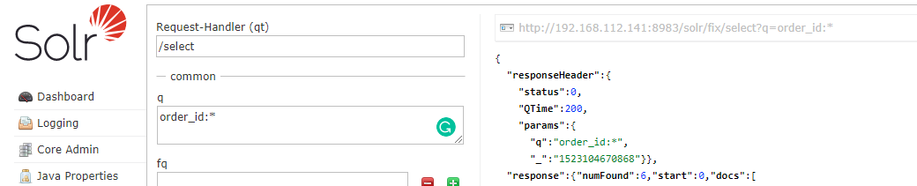

Use any order_id for testing: 337912000000003

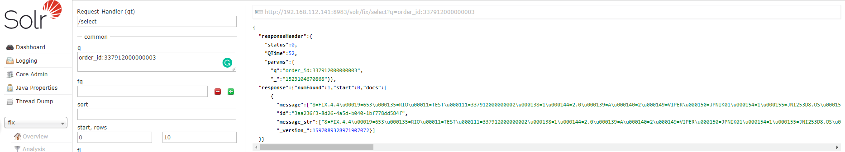

POST URL:

<http://192.168.112.141:8983/solr/fix/select?q=order_id:337912000000003>

GET Response:

{

"responseHeader":{

"status":0,

"QTime":3,

"params":{

"q":"order_id:337912000000003"}},

"response":{"numFound":1,"start":0,"docs":[

{

"message":["8=FIX.4.4\u00019=653\u000135=RIO\u00011=TEST\u000111=337912000000002\u000138=1\u000144=2.0\u000139=A\u000140=2\u000149=VIPER\u000150=JPNIK01\u000154=1\u000155=JNI253D8.OS\u000156=XSVC\u000159=0\u000175=20180350\u0001100=XOSE\u000110039=viperooe\u000110241=viperooe\u0001150=A\u0001372=D\u0001122=20180320-08:08:35.038\u000110066=20180320-08:08:35.038\u000110436=20180320-08:08:35.038\u0001202=25375.0\u000152=20180320-08:08:35.088\u000160=20180320-08:08:35.088\u000110071=20180320-08:08:35.088\u000111210=337912000000002\u000137=337912000000002\u000110184=337912000000002\u0001201=1\u000129=4\u000110438=RIO.4.5\u000110005=178\u000110515=178\u000110518=178\u0001581=13\u0001660=102\u00011133=G\u0001528=P\u000110104=Y\u000110202=APMKTMAKING\u000110208=APAC.VIPER.OOE\u000110217=Y\u000110292=115\u000111032=-1\u0001382=0\u000110537=XOSE\u000115=JPY\u0001167=OPT\u000148=179492540\u0001455=179492540\u000122=101\u0001456=101\u0001151=1.0\u0001421=JPN\u000110=200\u0001\u0002\r\n"],

"id":"3aa236f3-8d26-4a5d-b040-1bf778dd584f",

"message_str":["8=FIX.4.4\u00019=653\u000135=RIO\u00011=TEST\u000111=337912000000002\u000138=1\u000144=2.0\u000139=A\u000140=2\u000149=VIPER\u000150=JPNIK01\u000154=1\u000155=JNI253D8.OS\u000156=XSVC\u000159=0\u000175=20180350\u0001100=XOSE\u000110039=viperooe\u000110241=viperooe\u0001150=A\u0001372=D\u0001122=20180320-08:08:35.038\u000110066=20180320-08:08:35.038\u000110436=20180320-"],

"_version_":1597089328971907072}]

}}

To create index for the whole directory:

Before:7 documents

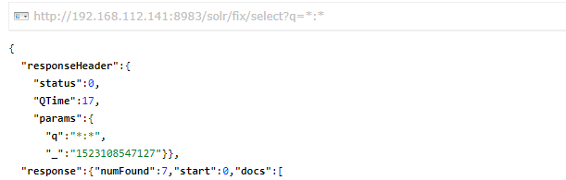

Directory of files: ./post -c myfiles ~/Documents

bin/post -c fix /home/data/data

/home/data/data: 20 documents

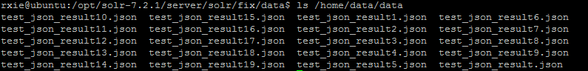

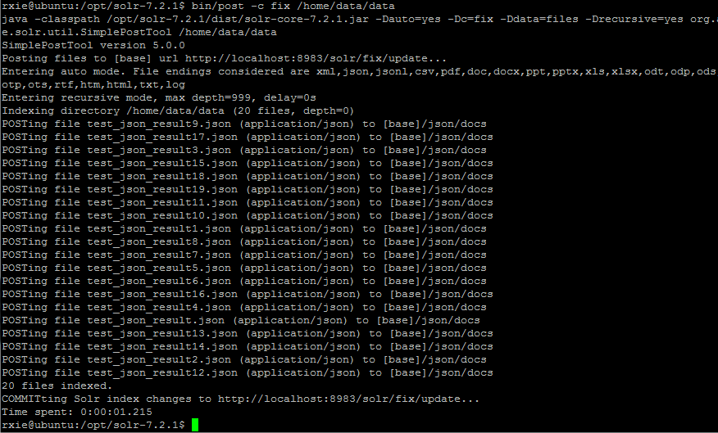

Check the Solr Admin, now there are 27 documents indexed:

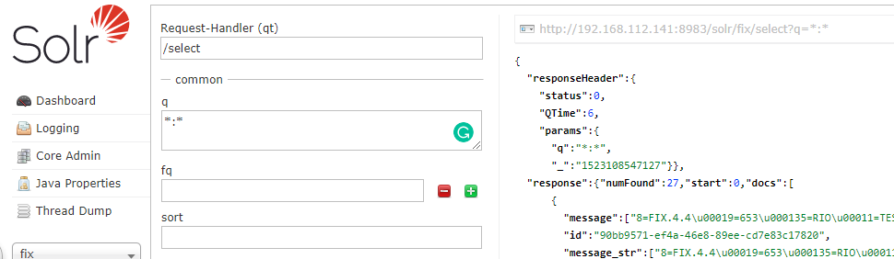

Search a newly added one: 337912000000019

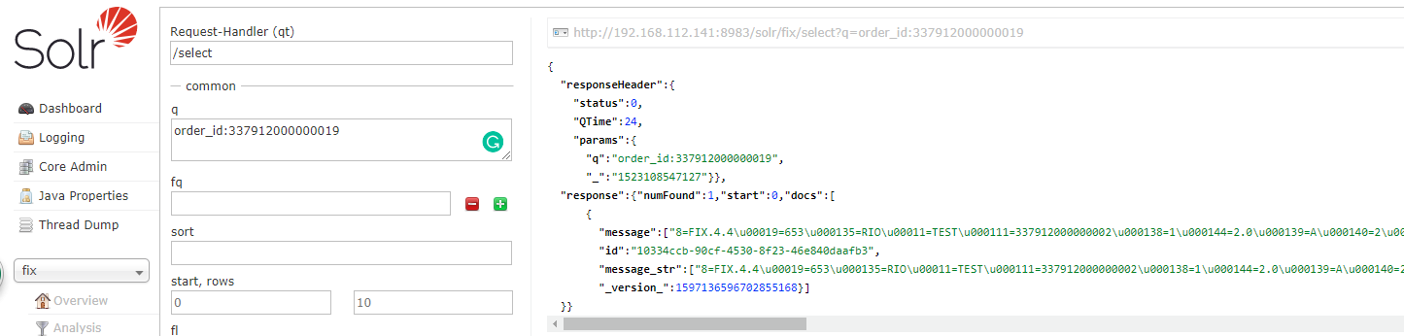

Install fix2json

1. Install ngm:

sudo apt install npm

1. Install fix2json

sudo npm install -g fix2json

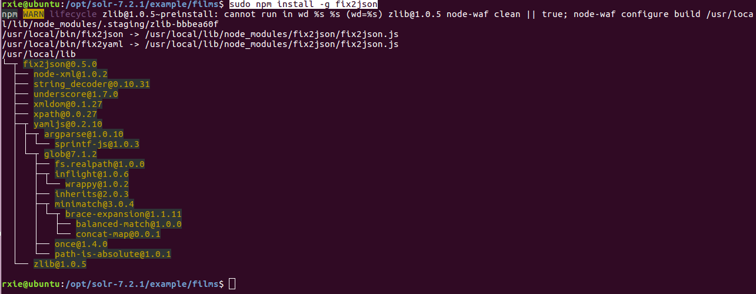

Install openssh

sudo apt-get install openssh-server

Connect with FileZilla

